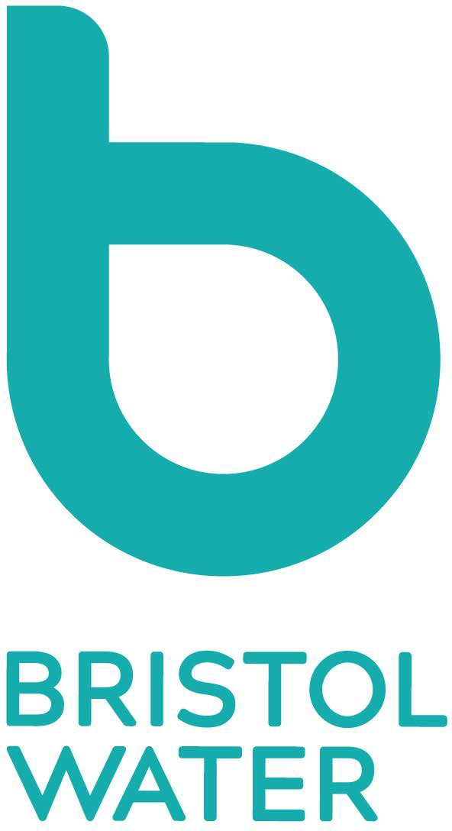
 | SL-N2 Request for Bristol Water to Complete a Spur Connection
This application form should be used when you are ready for the branch connection for the development detailed below. We will aim to make the connection within 21 days from receipt of your complete request for the work form. For connections with work complexity or legislative restrictions where the connection cannot be completed within 21 days we will provide an alternative date for the connection within 9 calendar days of receiving the completed notification form. Please send form to NetworkSiteAgents@bristolwater.co.uk.
1. Scheme Details
Site Name: | Developer:
SLP: | Bristol Water Application Number (e.g.MLA 1234567):
2. Mandatory requirements
1. Has the signed self lay agreement been returned to Bristol Water? |  |  |  | Yes |  |  |  |  | No
2. Has the Developer’s payment been paid? |  |  |  | Yes |  |  |  |  | No
3. Are the new road, lines and levels in? |  |  |  | Yes |  |  |  |  | No
4. Is the connection area free from obstruction / open excavations? |  |  |  | Yes |  |  |  |  | No
5. Are there any traffic management restrictions? |  |  |  | Yes |  |  |  |  | No
If applicable please add any additional comments below:
3. Completion Date
The date by which the spur needs to be completed: |  | D | D |  | M | M |  | Y | Y | Y | Y

SL-N2 Request for Bristol Water to Complete a Spur Connection v3 14/01/2018 p1 of 1

